This FECV Assessment is best referenced in tandem with landowner and logger training and outreach materials developed collectively, or individually, by the Lake States SFI Implementation Committees (SIC)s. This replaces all previous versions.

Table of Contents
Summary 2
Background 2
Methods 3
Results 4-15
Presence of G1/G2 Species & Ecosystems 4
Regional Biodiversity Significance 4-5
Groupings 5-6
Aquatic Species 5
Open Ecosystems and Associated Species 5
Distribution 6
Extremely Rare Species 6
Forestry-Impacted Species 6-15
Northern Long-Eared Myotis (Bat) 7
Indiana Bat 8
Wood Turtle 9
Karner Blue 10
Little Goblin Moonwort 11
An Ambersnail 12
Jack Pine / Prairie Forbs Barrens 13
Northern White-cedar / Yellow Birch Forest 14
Laurentian Pine Barrens 15
Discussion 16
Periodic Review 17

Tables & Figures
Figure 1: Lake States G1/G2 Species and Ecosystems 4
Figure 2: Map of Biodiversity Importance 5
Figure 3: FECVs Potentially Negatively Impacted by Forest Management 6

Summary

In accordance with the requirements of the 2022 SFI Fiber Sourcing Standard, the SFI Implementation Committees of the Lake States (MI, MN, and WI) worked cooperatively on an assessment of Forests with Exceptional Conservation Value (FECVs). Lists of Globally Critically Imperiled (G1) and Imperiled (G2) species and ecosystems were acquired from NatureServe for each state. Trained biologists and foresters reviewed each entry and evaluated the potential for forestry activities to impact the FECV (positively and/or negatively). The process resulted in focused lists of species and ecosystems that could benefit from additional education, information, and mitigation to ensure their continued presence on the landscape. The SICs and SFI certified organizations will use this information to develop training materials and programs for wood producers, foresters, loggers, and private non-industrial forest landowners within their fiber procurement regions. Periodically this assessment will be reviewed for changes to the Globally Critically Imperiled (G1) and Imperiled (G2) species and ecosystems listed by NatureServe. Appropriate modifications for this assessment will be applied.

Background

Sustainable Forestry Initiative (SFI) certified organizations have been supporting biodiversity conservation since their initial certification to the Fiber Sourcing standard. While some of the Forests with Exceptional Conservation Value (FECV) related requirements in the SFI 2015-2019 Fiber Sourcing Standard did not change, the 2022 SFI Fiber Sourcing Standard introduces new requirements and approaches to promote and conserve FECVs.

The 2022 SFI Fiber Sourcing Standard Objective 1. Biodiversity in Fiber Sourcing; Performance Measure 1.2. Promotion and conservation of Forests with Exceptional Conservation Value; Indicator 1 states, “Certified Organizations shall conduct an assessment, individually and/or through cooperative efforts involving SFI Implementation Committees, of Forests with Exceptional Conservation Value, defined as critically imperiled and imperiled species and ecological communities, within their wood and fiber supply area(s) and make the summary of the assessment available to wood producers.”

Ultimately, SFI-certified organizations are responsible for demonstrating conformance with the new requirements of the 2022 SFI Standard. However, SFI Implementation Committees (SICs) provide an opportunity for SFI-certified organizations to collaboratively leverage activities to meet SFI certification requirements in a cost efficient, expeditious and mutually beneficial way. Multilateral cooperation amongst SFI-certified organizations operating in similar geographies, with similar markets and similar forest ecosystems increases efficiency and provides regional consistency in messaging and forest management practices.

Following are examples of activities conducive to regional and in-state SIC collaboration that can help SFI-certified organizations meet the FECV Standards:
- Gathering and analyzing scientific information on Globally Critically Imperiled (G1) and Imperiled (G2) species and ecosystems.
- Engaging in or supporting regional research on G1/G2 species and ecosystems.
- Sharing experiences and knowledge on best practices that can be implemented to address G1/G2 species and ecosystems.
Developing and distributing educational and informational materials to wood producers, loggers, foresters, and landowners.
Methods

Regional Similarities: The Lake States of Michigan, Minnesota, and Wisconsin share very similar forested landscapes. All historically had native prairies in the south, a hardwood transition zone mid-state and conifer grading to boreal forests in the north. All three have climatic influence from the Great Lakes. The historical logging patterns in each state were virtually identical in nature, with slight temporal variation. The current forests are oak-hickory-maple in the transition zone and aspen-spruce-pine in the north. The industries are also similar, with hardwood sawmills in the south, softwood sawmills and pulp mills in the north. Additionally, the three states have similar forest landowner patterns, state agency organizations and forestry best management practices (BMPS).

Committee Process: Given the regional similarities, the three SICs elected to work together on this FECV assessment and any subsequent educational and informational efforts. Representatives from the Lake State SICs participated in the FECV Playbook Training session, and then formed an ad hoc FECV Committee (Appendix A) to develop the processes to conduct the FECV Assessment. The Committee met once virtually to develop the scope of work, discuss document sharing and make work assignments. The ad hoc FECV Committee met in person during the 2022 SFI Annual Conference in Madison, WI to review progress on individual state assessments, agree to the process, and set a timeline. We also attended the SIC General Session dedicated to FECV assessments. Once the data was analyzed and consensus reached, the FECV Committee members crafted this document and circulated it to the MN, WI and MI SICs for review and approval. In 2023 and 2025 the ad hoc group met to discuss updates and coordinated in compiling and publishing updated assessments.

Data Gathering & Analysis: We used NatureServe Explorer (https://explorer.natureserve.org/) to export Excel spreadsheets of all G1 and G2 species and ecosystems for each state (MI, MN, and WI). We then added columns to the spreadsheets as part of the effort to assess the impacts of forestry activities to each FECV. Column data and color-coding indicate:
- Educated determinations of (N) – Not Impacted by Forest Management, (P) – Potentially Impacted by Forest Management, or (I) – Impacted by Forest management. Impact level was color-coded such that Green indicates no impact by forestry, Yellow indicates a potential impact, and Red indicates an impact from forestry.
- The nature of the potential impact (positive, negative or both) and a brief explanation. This was done only for P or I species and ecosystems.
- If existing forestry Best Management Practices (BMPs) address the impacts (yes or no). This was done only for P or I species and ecosystems.
- Notes of any additional mitigation recommendations.

SIC members with appropriate knowledge and expertise on wildlife ecology, biology, and forestry (individually or cooperatively) reviewed NatureServe’s data on the FECV species and ecosystems, consulted as needed with other subject experts and resources, and then made a professional determination of the forestry impacts on each FECV. Only species and ecosystems lacking sufficient BMPs that were ranked as (I) - Impacted by forest management or (P) – Potentially Impacted by forest management where the nature of the impact was negative or both positive and negative were prioritized for further action in this assessment. These are attached as Appendices B-D to this document, serve as the heart of the assessment, and guide future educational efforts directed towards foresters, loggers, landowners, and the public.

Results

Presence of G1/G2 Species & Ecosystems:
Combined, the Lake States contains 230 G1/G2 species and ecosystems, distributed similarly among broad classification groups (Figure 1). As expected, there is considerable overlap between the states.
- Species: There are 16 G1/G2 species found in all three states and 26 more found in two of the three states (Appendix E).
- Ecosystems: There are 12 G1/G2 ecosystems found in all three states, and another 12 found in two of the three states (Appendix F).

Figure 1: Lake States G1/G2 Species and Ecosystems
Classification | Minnesota | Michigan | Wisconsin
Crayfish, Shrimp, & Other Crustaceans | 0 | 1 | 2
Fungi | 2 | 0 | 0
Insects | 24 | 19 | 12
Lichens | 3 | 0 | 2
Mussels, Snails, & Other Mollusks | 7 | 7 | 11
Nonvascular Plants | 3 | 3 | 0
Other Invertebrates - Terrestrial/Freshwater | 2 | 0 | 0
Vascular Plants - Ferns and relatives | 2 | 3 | 2
Vascular Plants - Flowering Plants | 2 | 7 | 3
Vertebrates | 2 | 5 | 2
Forest Ecosystem | 6 | 11 | 8
Prairie Ecosystem | 10 | 12 | 8
Savanna/Barrens Ecosystem | 5 | 6 | 6
Wetlands Ecosystem | 7 | 7 | 5
Other Ecosystem | 1 | 6 | 5
Total | 76 | 87 | 66

Regional Biodiversity Importance:
It is important to note that the timber management zone of the northern Lake States has relatively few imperiled species compared to other regions in the US. Figure 2 is a map of Biodiversity Importance produced by NatureServe that clearly shows that northeast Minnesota, northern Wisconsin, and the Upper Peninsula of Michigan do not have high concentrations of imperiled species. Within Minnesota and Wisconsin, the highest concentrations of imperiled species/ecosystems and thus the greatest biodiversity importance occur outside of the forested areas most frequently harvested/utilized for wood fiber. This is largely because the landscapes are dominated by natural forest ecosystems, and that forest management, harvesting and utilization has been conducted responsibly in ways that support and conserve existing biodiversity.

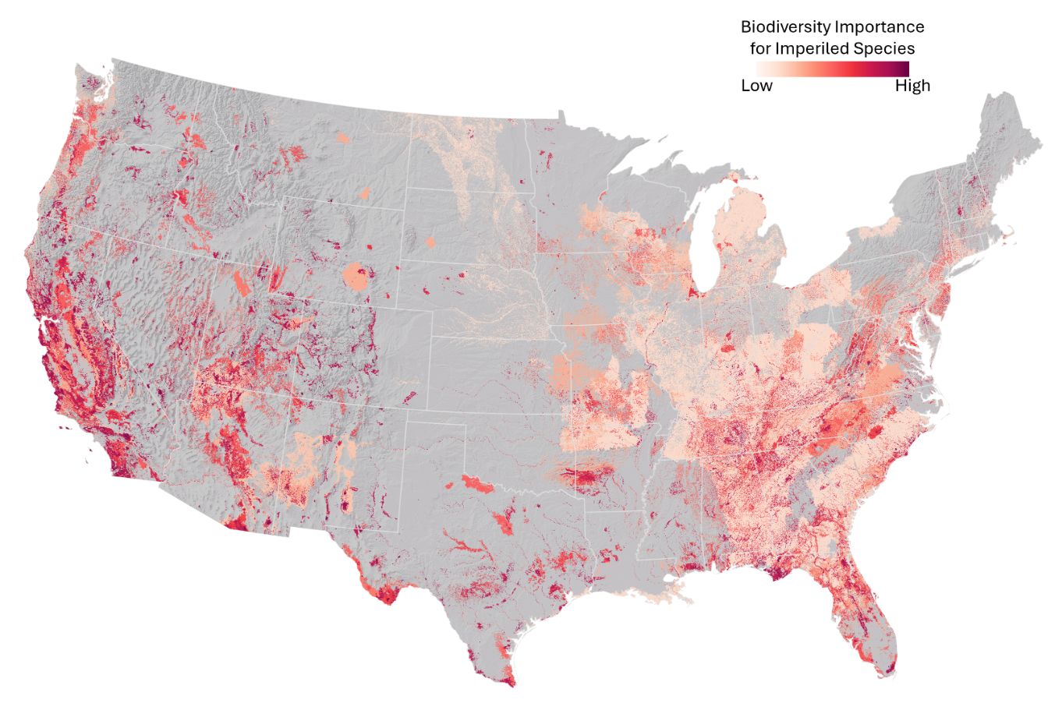
Figure 2: Map of Biodiversity Importance (https://www.natureserve.org)

Groupings:
The Assessment found that many of the FECVs (G1/G2 species and ecosystems) are not impacted by forestry activities because they are unforested or do not use forested habitats in their life cycles. There are others that could potentially be impacted by forestry activities, both positively and negatively. Accordingly, we grouped the key FECVs and considered mitigation actions.
- Aquatic Species: There are a few fish, many insects (caddisflies, mayflies, dragonflies, and stoneflies), and gastropods (mussels, snails, & other mollusks) listed in all three Lake States. Many of these are associated with river systems. There is the potential for forestry activities (especially road construction, landings, and timber harvesting) to result in erosion that could negatively impact these species. However, each state has site level forest management water quality best management practices (BMPs) in place. Loggers are trained to these BMPs and implementation monitoring shows a high level of compliance. The small amount of non-compliance is insufficient to result in negative impacts to these species.
- Open Ecosystems and Associated Species: There are nearly 100 prairie, dune, open wetland, pavement, shrubland, talus slope, savanna, and barrens ecosystems listed for the region. Prairie, savanna, and barrens systems were historically cleared for agriculture and development and are subsequently rare today. They require frequent disturbance from variable intensity wildfires or fires of aboriginal origin to maintain their open condition. Without disturbance, some succeed into woodlands and forests, while others are too nutrient-poor to support trees. Forest management activities (logging) can be a tool to maintain and restore the open character of these ecosystems or to reduce the risk of prescribed burning escaping and causing damage. Conversely, tree planting could transition openlands into forests, or convert native forest to other types (e.g., jack pine converted to red pine). Landowners should be educated to recognize rare native open landscapes and encouraged to manage them accordingly.
- Distribution: Some G1/G2 species and ecosystems are not found within the fiber procurement zones of SFI-certified organizations. Others are found in forest types not typically utilized by SFI-certified organizations. This was taken into consideration during the Assessment and referenced when determining priority landowner outreach and logger training action items.
- Extremely Rare Species: Throughout the Lake States there are extremely rare species and ecosystems that are artifacts of historic conditions or result from speciation, specialization, and geological/geographical conditions. Some are thought to be extinct; others are historic records that lack confirmation, and yet others are found in one or two locations. Due to their rarity, the fact that a large proportion of timber harvest in the region occurs in winter, and high level of BMP compliance in the Lake States, this assessment concluded that there is a low likelihood of negative impacts from forestry activities on those species or ecosystems.

Forestry-Impacted Species:
The assessment found that of the identified G1/G2 species and ecosystems documented by NatureServe in the Lakes States, only the species and ecosystems listed in Figure 3 could be negatively impacted by forest management activities to the degree action is warranted by SFI-Certified organizations and/or SICs (Appendices B-D). Although there are species and ecosystems that are shared between the Lake States, the ranking of those individuals does not always match neighboring states.

Figure 3: FECVs Potentially Negatively Impacted by Forest Management
Common Name | Minnesota | Michigan | Wisconsin
Northern Long-Eared Myotis | Impacted | Impacted | Impacted
Karner Blue | Possibly Impacted | No Impact | Impacted
Little Goblin Moonwort | Impacted | Impacted | Impacted
An Ambersnail | Not Found | Impacted | Not Found
Indiana Myotis | Not Found | Impacted | Not Found
Wood Turtle | Impacted | Impacted | Impacted
Jack Pine / Prairie Forbs Barrens | Impacted | Impacted | Impacted
Northern White-cedar – | Impacted | Impacted | Impacted
Yellow Birch Forest | Impacted | Impacted | Impacted
Laurentian Pine Barrens | Not Listed | Impacted | Possibly Impacted

The following pages include summaries of the above species and ecosystems that are determined to be impacted by forest management activities in at least one of the Lake States. This information will be utilized in future logger and natural resource professional trainings and included in landowner outreach materials.
Each is shown on a separate page to allow for easier reader navigation, updating as the status of them change, and use of this information by SICs and SFI-certified organizations.
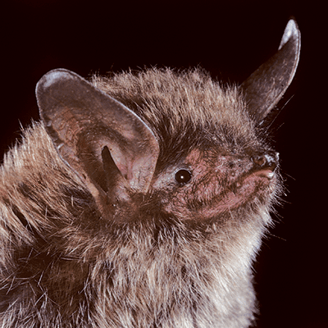
Northern Long-Eared Myotis

Myotis septentrionalis, commonly known as the Northern Long-eared Bat (NLEB), is one of four non-migratory forest bat species in the Lake States that have suffered dramatic population declines due to contracting white-nose syndrome (WNS). White-nose syndrome is the result of infection of the non-native fungus Pseudogymnoascus destructans, which causes the bats to come out of hibernation mid-winter and die due to starvation and dehydration. On March 31, 2023, the NLEB was reclassified as endangered.

Forested habitat loss is not contributing to NLEB decline. In fact, forest management helps create travel corridors and foraging habitat for the species. But female bats use old, loose-barked trees as maternal roost trees – places where females congregate to rear their pups in summer. Loss of these trees or too much timber harvesting near hibernacula could negatively impact the few surviving animals. Since their Threatened listing forest management has occurred under the NLEB 4(d) Rule, which specifies no timber harvest within a 0.25-mile (0.4 kilometer) radius of known northern long-eared bat hibernacula; and no harvest of known occupied maternity roost trees, or any other trees within a 150-foot (45-meter) radius from the known maternity tree during the pup season (June 1 through July 31). Lakes States state agencies developed a Habitat Conservation Plan (HCP) to seek an incidental take permit from the US Fish & Wildlife Service for state-managed land and allows other large landowners to enroll under the incidental take permit (ITP). This HCP and ITP ensure forest management and related activities can continue on DNR-managed land without additional consultation from USFWS. Additional large landowners can extend take authorization through the ITP through a Landowner Enrollment Program, which is currently being developed by each state’s DNR.

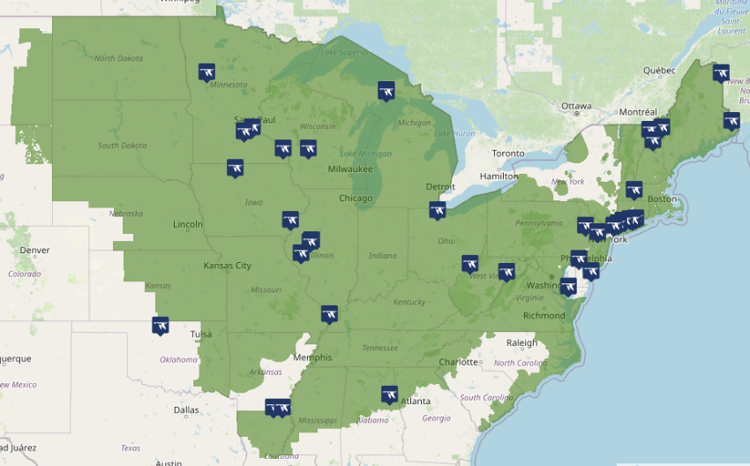
All three Lake States consider NLEB Impacted by forest management activities and encourage foresters, landowners, and loggers to be aware of their plight, to perform the appropriate risk analysis to reduce the likelihood of take, and to check with the state agency before timber management to ensure there are no known, occupied roost trees on properties. If there are, they should follow the recommendations of the HCP to protect the species’ habitat.
Source: US Fish & Wildlife Service
More Resources:
  - US Fish & Wildlife Service
  - NatureServe
  - NLEB Endangered Uplisting Final Rule
  - Lake States Forest Bat HCP
  - White-Nosed Syndrome Response Team
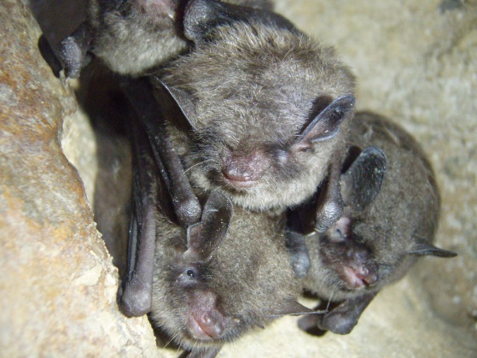
Indiana Bat

Myotis sodalis is a small, insectivorous, migratory bat that hibernates colonially in caves and mines in the winter. The species was originally listed as in danger of extinction under the Endangered Species Preservation Act of 1966 and is currently listed as endangered under the Endangered Species Act of 1973. The current population has declined by half compared to when the species was listed as endangered.

Indiana bats require forests for foraging and roosting and are found in forested areas in the eastern half of the United States. In winter, Indiana bats hibernate in caves and mines. They are highly concentrated during hibernation, with 72% of the population hibernating in just four sites.

Threats to the species include human disturbance of hibernating bats, commercialization of caves where the bats hibernate, loss of summer habitat, pesticides, and other contaminants, and most recently, the disease white-nose syndrome. The greatest single cause of loss of forest habitat within the range of the species is urbanization and development, but the forested habitat used by this species remains extensive and probably is not limiting the population.

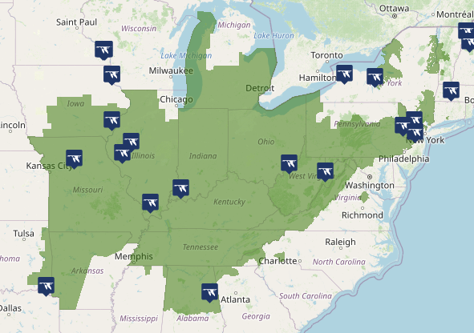
White-Nose Syndrome (WNS) is the result of infection of the non-native fungus Pseudogymnoascus destructans, which causes the bats to come out of hibernation mid-winter and die due to starvation and dehydration. The range-wide population has declined by 19% since 2007, when white-nose syndrome first arrived in North America.

The species is not found in Minnesota or Wisconsin. The Michigan assessment listed it as Impacted by forest management due to the species use of forests for maternal roost colonies, using the same areas year after year.
Source: US Fish & Wildlife Service

More Information:
  - NatureServe
  - US Fish & Wildlife Service
  - Bat Conservation International
  - Michigan State University

Wood Turtle
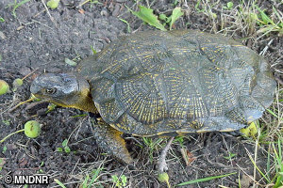
Glyptemys insculpta is a relatively small, long-lived, relatively terrestrial turtle primarily associated with forested river systems. The wood turtle is listed as Threatened in all three of the Lake States and is considered a G2 species by NatureServe. It occurs in small, increasingly disjunct subpopulations, many of which are separated from each other by distances greater than the species can be expected to disperse.
Wood turtles live along permanent streams during much of each year but in summer may roam widely overland and can be found in a variety of terrestrial habitats adjacent to streams, including deciduous woods, cultivated fields, woodland bogs, and marshy pasture. Western populations are closely associated with water year-round, and eastern populations tend to be more terrestrial in the summer. Sandy, sparsely vegetated areas that are not prone to flooding and have ample exposure to direct sunlight provide important nesting sites.
This species has been declining in abundance for decades throughout its range, but the range has not contracted. One of the primary reasons behind the population decline is a very low rate of nests hatching and a low rate of juveniles surviving to adulthood, which takes 14-18 years. It is also impacted by habitat loss and degradation, heavy predation by natural predators, direct mortality from road vehicles and agricultural equipment, habitat loss and degradation, illegal collection, and climate change. Habitat loss threat is somewhat lessened by this species’ tolerance of moderate development or disturbance, such as second homes, timber harvest, light grazing, and low-intensity agriculture.
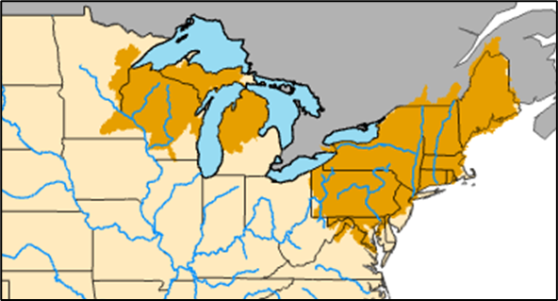
All three Lake States consider wood turtles Impacted by forest management activities, although those activities can be positive or negative depending on scope and scale. We encourage foresters, landowners, and loggers to be aware of their plight, to perform the appropriate risk analysis to reduce negative impacts.

Source: United States Geological Service
More Information:
  - NatureServe
  - US Fish & Wildlife Service
  - Minnesota DNR
  - Wisconsin DNR
  - Michigan State University
  - USDA Forest Service
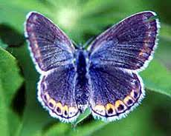
Karner Blue

Plebejus samuelis is an endangered (1992) subspecies of small blue butterfly found in portions of eastern Minnesota, Wisconsin, and Michigan. Its life cycle depends on the wild blue lupine flower (Lupinus perennis), found in oak savannas and pine barrens habitats as well as in frequently disturbed areas.

These open habitats were often cleared for agriculture, but also suffer from the lack of fire on the landscape to maintain the open character for the butterfly’s host plant. Without disturbance savannas and barrens can transition into more closed-canopy woodlands. Therefore, forestry can have a positive impact on the species if used to maintain these open habitats, or a negative impact if they are planted into other species or managed as woodlands or forestlands.

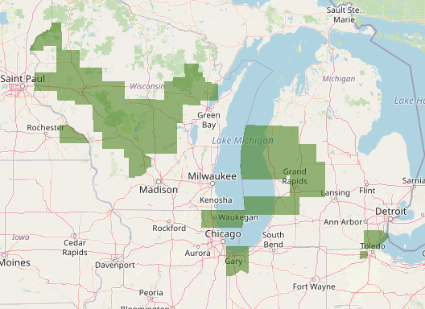
This species is found in all three states but is classified differently in each. Wisconsin has the largest and best habitat and has listed the Karner Blue as Impacted by forest management. The DNR and 50 partners have signed a Habitat Conservation Plan with the USFWS. Minnesota has a small population in the southeast. Their assessment found that the species was Possibly Impacted by forest management, but the population is small and isolated, is outside of the primary SFI certified organization procurement range and the biggest threat is a lack of forest management leading to succession. The Michigan assessment concluded forest management has No Impact on Karner Blue for the same reasons.

Source: US Fish & Wildlife Service

More Resources:
  - USFWS Karner Blue
  - NatureServe
  - Karner Blue Habitat Conservation Plan
  - Wisconsin DNR
  - Minnesota DNR
  - Michigan DNR

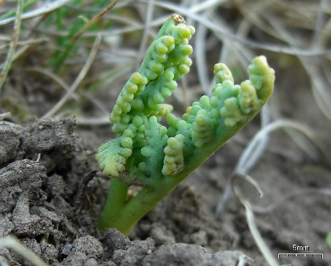
Little Goblin Moonwort

Botrychium mormo is a small species of moonwort found in rich hardwood forests in the northern portions of Minnesota, Wisconsin, and Michigan, and one site in Quebec. It grows in loamy soils with rich organic matter on shaded forest floors in mature maple-basswood and maple-basswood-beech forests. Habitats are typically north-facing hillsides, possessing moist, mineral-rich soils. It is a mycorrhizal species that can remain underground for many years until habitat conditions improve.

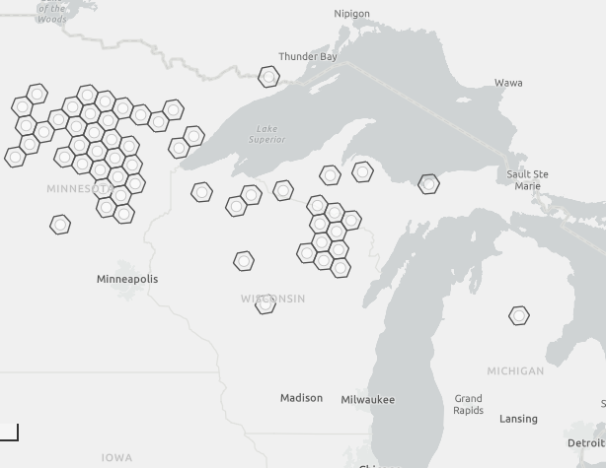
Non-native earthworms are a major threat range wide and have shown to cause dramatic declines. Any activity that opens the forest canopy and increases the effects of soil desiccation is likely to be detrimental to the species. Planting monocultural pine plantations and ground-layer herbicide application are other threats to this species. Grazing can compact the forest soil, remove, or damage existing plants, and damage overstory trees.

All Lake States assessments found that forest management Impacts the species. Populations are well-documented. It is unknown exactly what level of disturbance the species can tolerate given its mycorrhizal nature, but care should be taken to avoid drying the soil.
Source: Nature Serve

More information:
  - NatureServe
  - Wisconsin DNR
  - Minnesota DNR
  - Michigan State University
  - Chippewa National Forest

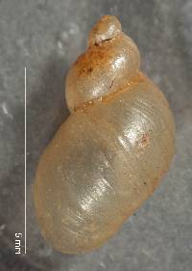
An Ambersnail

Catinella protracta is a terrestrial snail with a fragile, translucent yellow shell that grows up to .6 inches in length, commonly with 3 whorls, and features a large oval aperture and sharp lip. The snail's body is light brown to gray, broad at the front, tapering behind with short and thick eye peduncles and tentacles. The mantle is pale grey spotted with black and white.

This species is found in a variety of habitats, such as carbonate cliffs, alvars, grasslands, beneath leaf litter, logs and stones on the forest floor, lakeshores, dunes, ditches, and pastures in southern Michigan. It is known from 6 observations, most recently in 1975.

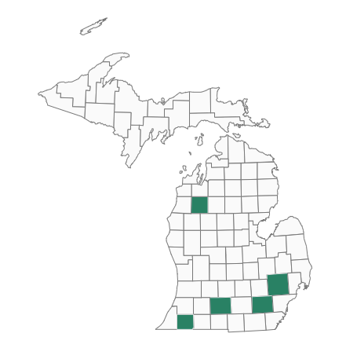
Habitat loss, fragmentation and degradation are considered the greatest threats to land snail species. Dependence on specific microhabitat conditions renders many species vulnerable to changes brought about by increased edge area, forest canopy reductions, and the loss of vegetative ground cover. Fire can negatively affect land snail populations and microhabitats. Large, downed logs may provide important refuges during periods of fire and drought and should be retained. Heavy recreational traffic may negatively impact snail habitat. Identifying and protecting areas of suitable habitat will aid Catinella protracta.

The species is not present in Minnesota or Wisconsin. The Michigan assessment listed it as Impacted by forest management since it is found in forested areas and the Michigan Natural Features Inventory specifically lists forest canopy reductions as a threat.
Source: Michigan State University

More Information:
- NatureServe
- Michigan State University

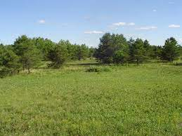
Jack Pine / Prairie Forbs Barrens

Jack Pine / Prairie Forbs Barrens ecosystems are found on the prairie/forest border in the US and Canada. The sandy soils are acidic, droughty, and infertile. The open vegetation was historically influenced by fires. The vegetation is dominated by grasses and forbs with a sparse tree layer. The dominant tree is jack pine (Pinus banksiana), with varying amounts of northern pin oak (Quercus ellipsoidalis), red pine (Pinus resinosa), and aspen (Populus spp.).

Fire is the most important natural disturbance in this community, keeping the tree canopy very open. In the absence of fire, oak becomes more abundant, leading to canopy closure and more shade-tolerant species establish. Many former sites of this type have become forests due to fire suppression or have been logged. Other sites have been converted to tree plantations.

All three state’s assessments listed this community as Impacted by forest management. Land managers should be aware of the community and avoid converting it to other species. Logging can be used to open the overstory before the reintroduction of fire as a management strategy.

More Resources:
  - NatureServe
  - Wisconsin DNR
  - Michigan State University
  - Minnesota DNR

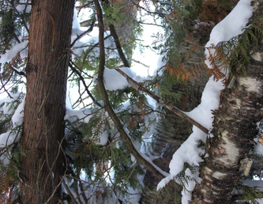
Northern White-cedar - Yellow Birch Forest
Northern White-cedar - Yellow Birch Forest ecosystems are found on well-drained to somewhat poorly drained upland soils across the Lake States. The canopy of this upland community is dominated by white cedar (Thuja occidentalis) and a variety of hardwoods, most typically yellow birch (Betula alleghaniensis), paper birch (Betula papyrifera), and quaking aspen (Populus tremuloides), but occasionally red maple (Acer rubrum) and sugar maple (Acer saccharum). Associated conifers include balsam fir (Abies balsamea), white spruce (Picea glauca), and (rarely) eastern hemlock (Tsuga canadensis).
There are probably fewer than 100 occurrences of this community range wide. Currently there is only one 14-acre occurrence documented from Minnesota. Several old growth stands have been documented on the Apostle Islands in Wisconsin.
All three states’ assessments listed this community as Impacted by forest management. Land managers should be aware of the community and avoid logging practices that could significantly alter composition. Both white cedar and yellow birch are difficult to regenerate, especially where white-tailed deer numbers are high.

More Resources:
  - NatureServe
  - University of Minnesota
  - Minnesota DNR (MHn45b)

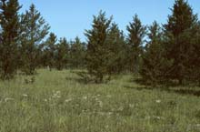
Laurentian Pine Barrens

Laurentian Pine Barrens ecosystems are found in the northern and western Great Lakes region. They occur primarily on sandplains/outwash soils, with dry, frequent fires. Jack pine (Pinus banksiana) typically dominates the canopy, but red pine (Pinus resinosa), northern pin oak (Quercus ellipsoidalis), and white pine (Pinus strobus) also are common overstory dominants. The understory is often quite low in diversity and open, with prairie species present.

Past logging practices combined with post-logging slash fires in some areas decreased the number of pines and created areas dominated by oak sprouts and scrubs. Fire suppression policies instituted in the 1920s resulted in the succession of many open pine barrens to closed canopy forests dominated by jack pine. Many sites formerly occupied by pine barrens were also converted to pine plantations. Other threats include livestock grazing, off-road-vehicle activity, and the invasion of non-native species.

This community is not listed in Minnesota. The Michigan assessment concluded it was Impacted by forest management due to the role logging and tree planting can play in altering the community. The Wisconsin assessment concluded it was Possibly Impacted. Land managers should be aware of the ecosystem and manage it for a low-density jack pine overstory and prairie-dominated understory using judicious logging and fire as management tools.

More Resources:
  - NatureServe
  - Wisconsin DNR
  - Michigan State University
  - Michigan DNR

Discussion

The Lake States SIC Forests with Exceptional Conservation Value (FECV) Assessment evaluated each G1 and G2 species and ecosystem documented by NatureServe and concluded that few were impacted by forest management activities in at least one of the Lake States. As outlined by the Fiber Sourcing Standard noted below, SFI-certified organizations assessed the impact of forest management activities and only those listed in Figure 3 may be impacted.

The 2022 SFI Fiber Sourcing Standard Objective 1. Biodiversity in Fiber Sourcing; Performance Measure 1.2. Promotion and conservation of Forests with Exceptional Conservation Value; Indicator 2 states SFI-Certified organizations must have a “Program to address Forests with Exceptional Conservation Value” (critically imperiled and imperiled species and ecological communities) for all harvest operations through fiber sourcing activities such as:
  - use of qualified logging professionals, certified logging companies (where available), and qualified resource professionals; or
  - training program for qualified logging professionals on how to recognize and protect Forests with Exceptional Conservation Value; or
  - through in-the-forest verification by certified logging companies; or
  - forest landowner outreach; or
  - SFI Implementation Committee involvement in the assessment of Forests with Exceptional Conservation Value, and development of recommendations for conservation.”

The SICs will work together to create educational materials for those that overlap and will work individually on the remainder. This will result in regionally consistent design and messaging around FECVs. These materials will provide more information on G1/G2 species and ecosystems, including:
- Identification
- General location
- How to secure proprietary specific locations
- Specific threats
- Mitigation
- Sources for more information

These materials will be used in FECV-specific training for wood producers, loggers, and foresters. They will also be incorporated into state SIC Landowner manuals and made available to other entities who routinely work with non-industrial private forest landowners (e.g., DNR private lands foresters, consulting foresters, Soil and Water Conservation Districts, etc.).

These state-based assessments, conducted in coordination across the Lake States, provide a thoughtful, science-based process for promoting the conservation of forestry-impacted globally critically impaired and impaired species. Providing key information to wood producers, foresters, loggers, and private landowners in the fiber procurement supply chain will help drive conservation of these species and ecosystems. This will serve to demonstrate SFI-certified organizations’ commitment to conserving biodiversity within their sphere of influence.

Periodic Review

Representatives from each Lake States SIC will periodically review the latest available G1/G2 species information from NatureServe to determine if updates are needed. The Lakes States working group will then be convened to review the overall regional assessment and determine if any findings warrant further actions to mitigate risk to FECV’s or specific species or ecosystems.

The 2025 review concluded that the frosted elfin (Callophrys irus) was removed from the G1/G2 species and ecosystems list and was thus removed from this assessment. The Wood Turtle (Glyptemys insculpta) was newly added to the G1/G2 list and is considered impacted by forestry activities.

